- First of all, we need to prepare,
- Android Studio
- JDK (about JDK, please google)
- Android SDK & the POSLink Android demo project
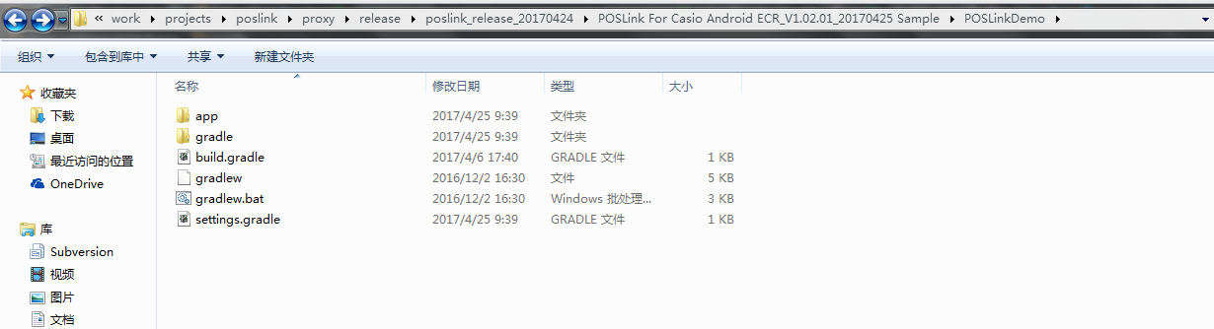

- Import the project to Android Studio
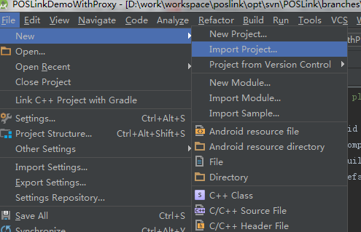
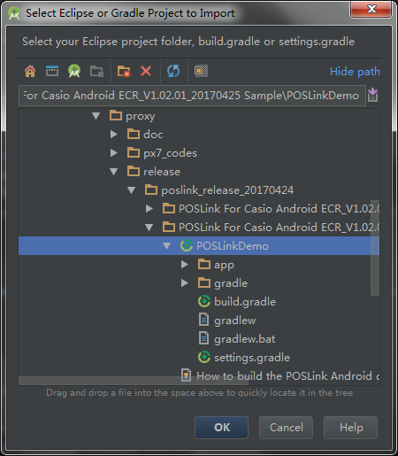

- Then click gradle sync

- Generate apk file
Click Menu”Build”->Generate Signed APK
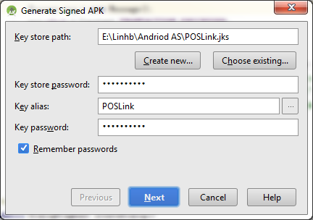
Create a new key if you don’t have,
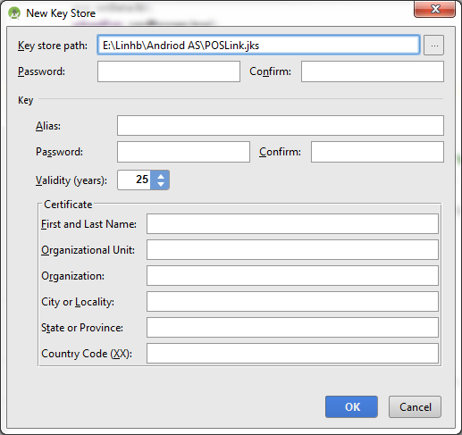

Then Click Next & Finish to generate the signed apk file.
